2017 Social Media Toolkit for Year-round Use: Healthcare Provider Audience
Below you will find draft acetaminophen safe use Twitter and Facebook posts for you to promote to your organizations as you see fit over the course of the year. If you have any questions regarding the contents of this toolkit, please contact Elizabeth Easterly at Elizabeth.Easterly@gmmb.com.

Thumbnail images are for reference only. All graphics can be downloaded at this link: https://gmmb.box.com/s/8v63m1g6o3idk582hpxmlfrbf65ubt9v

*To upload GIFs to Facebook, first copy and paste the media.giphy.com link to your Facebook post. The GIF should then populate. Delete the media.giphy.com link and replace with the post text before publishing.

Social Channel | Graphic | Text
Twitter | 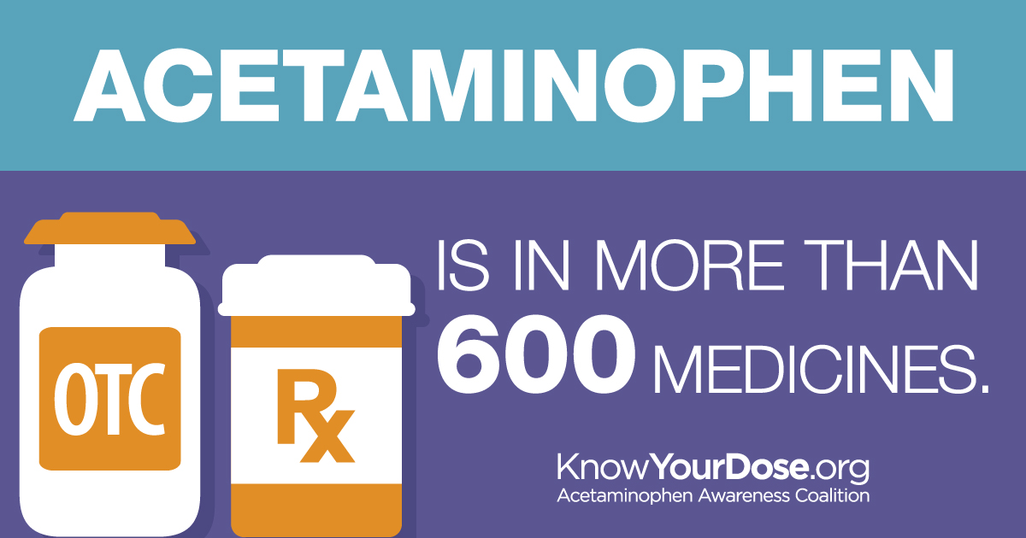 | Do your patients know taking 2 medicines with the same ingredient could be harmful? http://bit.ly/KYD-providers #KYDpain
Facebook |  | Do your patients know that taking two medicines with the same ingredient could be harmful? When a patient gets a cold or the flu, make sure they’re reading their medicine labels: http://bit.ly/KYD-providers #KYDpain
Twitter | 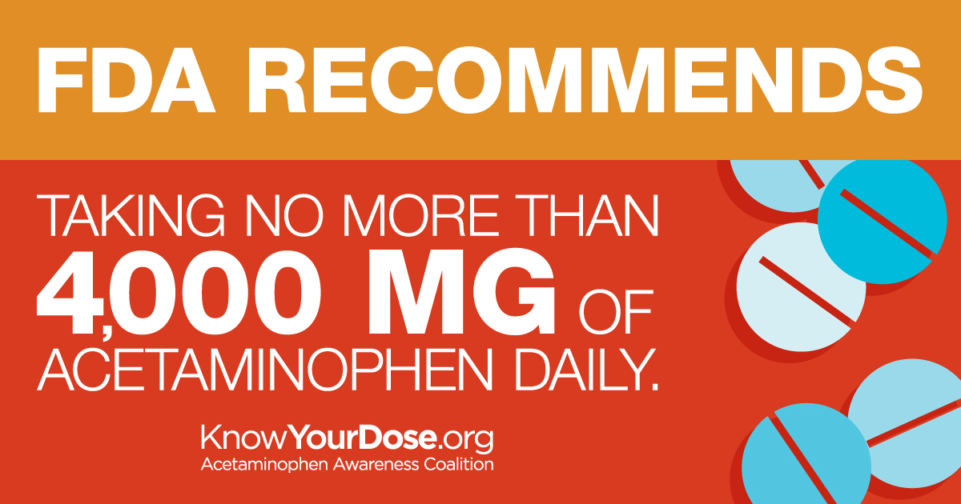 | Remind patients that there’s a limit to how much #acetaminophen they can safely take in 1 day: http://bit.ly/KYD-providers #KYDpain
Facebook |  | Remind patients that acetaminophen is safe and effective when used as directed. But they can only safely take so much in one day—taking more acetaminophen than directed can hurt their liver: http://bit.ly/KYD-providers #KYDpain
Twitter | 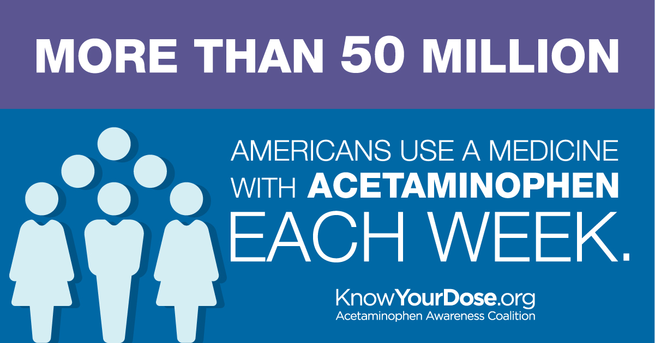 | 65% of people don't consider other OTC meds they take when choosing an OTC pain reliever—and should: http://bit.ly/KYD-providers #KYDpain
Facebook |  | 65% of people don't consider other OTC medicines they’re taking when they’re choosing an OTC pain reliever. Remind your patients to only take one medicine with acetaminophen at a time: http://bit.ly/KYD-providers #KYDpain
Twitter | 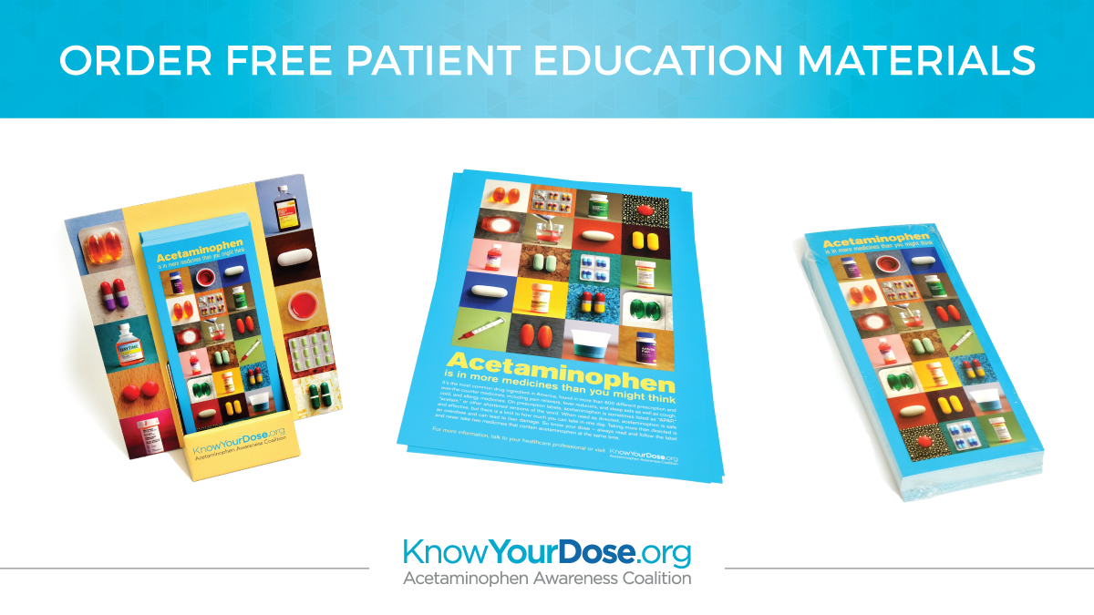 | .@KnowYourDose tools can help spark conversations w/ patients about #acetaminophen safe use: http://bit.ly/KYD-order #KYDpain
Facebook | 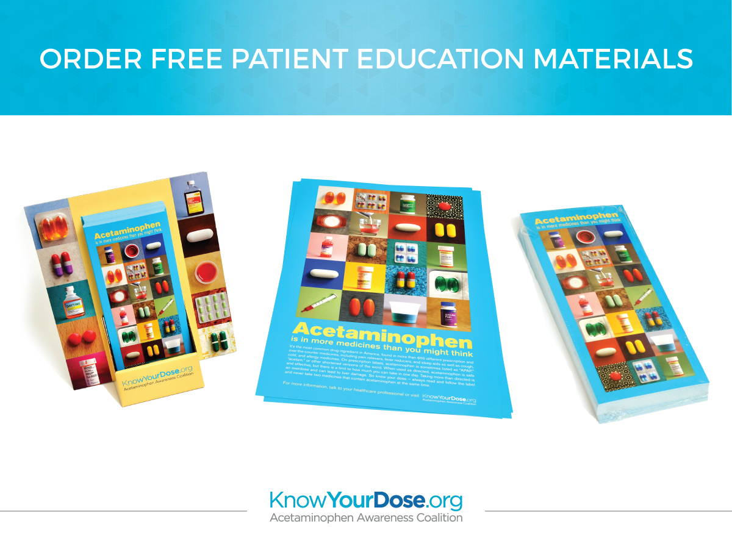 | Help remind your patients of acetaminophen safe use by displaying these educational materials from Know Your Dose: http://bit.ly/KYD-order #KYDpain
Facebook (video) | 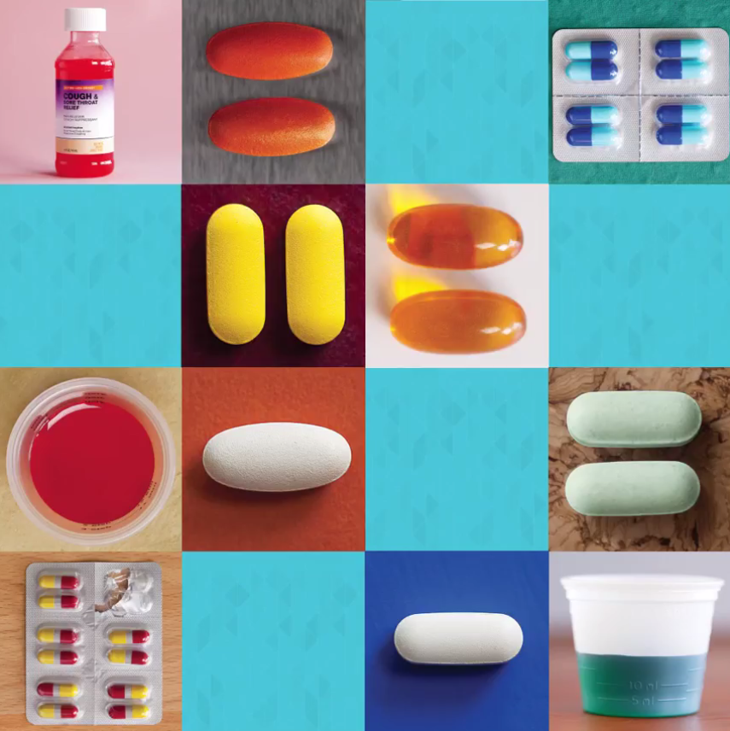 | Encourage patients to read and follow their medicine labels to avoid accidentally taking two medicines with acetaminophen at once: http://bit.ly/KYD-providers #KYDpain
Twitter (GIF) | 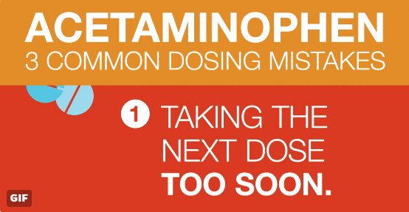 | Patients don’t always know the potential risks of double dosing on #medicine: http://bit.ly/KYD-providers #KYDpain
Facebook* (GIF) |  | Research shows patients don’t always know the potential risks of double dosing on medicine. Remind them to double check their medicine labels to avoid doubling up on acetaminophen: http://bit.ly/KYD-providers #KYDpain  https://media.giphy.com/media/xUA7aRrHsZbzccokko/giphy.gif
Twitter (GIF) | 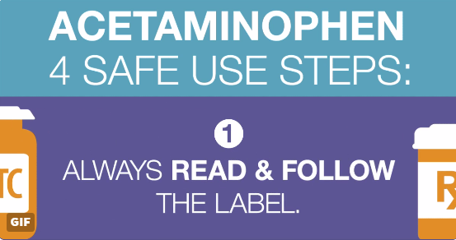 | Share these 4 #acetaminophen safe use steps with your patients: http://bit.ly/KYD-facts #KYDpain
Facebook* (GIF) |  | For patients who use OTCs for relief from cold symptoms or headaches, make sure they know these four safe use steps: http://bit.ly/KYD-facts #KYDpain  https://media.giphy.com/media/3o7bu4bKDwqqmGGz9S/giphy.gif

