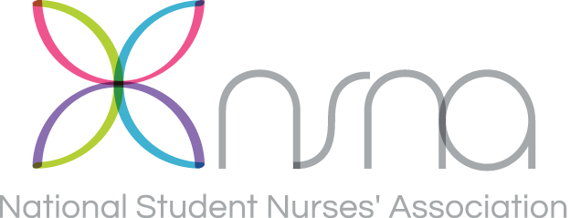
National Student Nurses’ Association, Inc.
45 Main Street, Suite 606, Brooklyn, NY 11201

Member Privacy Policy

Keeping Your Data a Private Matter
When it comes to confidentiality, you expect a relationship built on privacy and integrity. That’s why NSNA is very particular about how member information is shared with others. This policy outlines what we do to protect your personal information and describes how you can limit the sharing of this information.

Keeping Your Information Secure
To keep information confidential and appropriately protected, NSNA has policies that limit access to member’s personal information to only authorized NSNA employees who need it to perform their jobs and provide services to you. We also maintain physical, electronic, and procedural safeguards that guard your personal information.

Collecting Information
NSNA collects information that you provide on the membership application, renewal form, and when you notify NSNA of changes.

How Your Mailing Address is Used
Your mailing address is used to send you your membership card kit, membership renewal notice, Imprint magazine, NSNA Annual Convention brochure, NSNA MidYear Conference brochure, and other NSNA mailings as needed.

NSNA rents (one-time-use-only basis) the membership mailing list to exhibitors, Imprint advertisers, and organizations that provide NSNA member benefits. Revenue generated from this activity helps to support NSNA’s operations. The list may be rented to provide members with information about career opportunities, products, and services that NSNA members may find of interest. All such use is reviewed prior to releasing the list and is strictly monitored by NSNA to prevent unauthorized use. In addition, NSNA members may request additional information about the NSNA Partnership Program by checking the appropriate box on the membership application. If a member indicates that he or she wants additional information about the NSNA Partnership Program, the member’s address is shared with Partnership Program participants.

Member name, mailing address, phone number, school you attend, expected date of graduation, date you join and date that your membership expires are shared with respective state and school chapters for the purposes of: determining official NSNA and state association constituency status; membership status validation; state and school member mailings (i.e. newsletters and announcements). Information is provided to chapter leaders via electronic file, hard copy list, or mailing labels.

How Your E-Mail Address is Used
By providing your e-mail address you authorize NSNA to use it to communicate with you. You may unsubscribe at any time.
When you join NSNA, you also join a state student nurses association (unless there is no official NSNA state constituency in your respective state). NSNA provides state associations with a monthly report of all members who have joined the association the previous month. This report includes your membership number, name, mailing address, phone number, school you attend, expected date of graduation, and membership join/expiration dates. In addition, as of March 1, 2006, if NSNA has received a signed annual agreement from the respective state association stating that they will not release member e-mail addresses to third parties, the e-mail address is included in monthly state reports. NSNA also provides a service to state associations to send out broadcast e-mail to state association members. When a state association subscribes to this service, you will periodically receive messages from your state association via NSNA broadcast e-mail. Periodically NSNA conducts a member needs assessment and Imprint readership survey. Participation in surveys is voluntary.

How Your Demographic Information is Used
Type of nursing program, gender, year of birth, and race are collected for NSNA’s internal information only.

How Your Payment Information is Used
Payment information including credit card and checks is used solely for the collection of membership dues, conference/convention registration, and product purchase when applicable.

Storage of Data
NSNA does not retain computer files on individuals who are no longer members of NSNA. Membership records are retained for the period of time required by NSNA’s record retention policies, audit and Internal Revenue Service requirements. Sensitive personal data is shredded.

View Your Data
Members may view their own NSNA membership record online at www.nsna.org click on member services. Changes to your membership record may also be made online, by mail, by e-mail or via FAX.

Your Privacy Preferences
NSNA respects your right to restrict the information we disclose. You may notify NSNA of privacy concerns and you may direct NSNA not to share information about you by:
Calling 1-718-210-0705, Monday through Friday, 9 a.m. to 5 p.m. Eastern Time
FAX: 1-718-797-1186; Or via e-mail to: nsna@nsna.org
Writing to NSNA at:
National Student Nurses’ Association
45 Main Street, Suite 606, Brooklyn, NY 11201

Keeping You Informed
If NSNA’s information-sharing practices change, we will send you a revised notice.
Approved by the NSNA Board of Directors on February 12, 2006; amended March 2008; amended November 2013.

