2016 Cold and Flu Season Communications Toolkit for Healthcare Providers

Content for Twitter and Facebook

Thumbnail graphics are for reference only. All graphics are available for download at this link: https://gmmb.box.com/s/fwx6yih2390vo5fgd6dy6abj7yp3vwve

Social Channel | Graphic | Text
Twitter |  | This flu season, @KnowYourDose wants to help you talk with your patients about acetaminophen safe use: http://bit.ly/KYD-order #KYDcoldflu
Facebook |  | This cold and flu season, join the Know Your Dose campaign as we talk with our patients about safely using medicines containing acetaminophen: http://bit.ly/KYD-order #KYDcoldflu
Twitter | 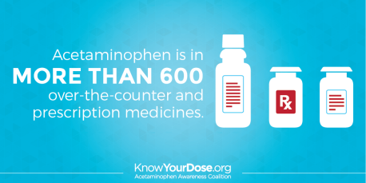 | Show this meds list to patients so they don't accidentally double up on acetaminophen in cold/flu meds: http://bit.ly/comm-meds #KYDcoldflu
Facebook |  | Share this list of medicines with your patients to help them avoid accidentally doubling up on doses of acetaminophen when taking multiple medicines during cold and flu season: http://bit.ly/comm-meds #KYDcoldflu
Twitter |  | 65% of people don't consider OTC meds they take when choosing an OTC pain reliever—your patients should: http://bit.ly/KYD-providers #KYDcoldflu
Facebook |  | 65% of people don't consider other OTC medicines they’re taking when they’re choosing an OTC pain reliever. It’s important to talk with your patients about this if they come down with a cold or the flu: http://bit.ly/KYD-providers #KYDcoldflu
Twitter | 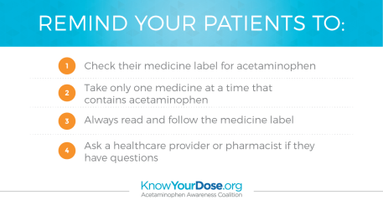 | It’s a great time of year to stock up on patient education materials about acetaminophen safe use: http://bit.ly/KYD-order #KYDcoldflu
Facebook |  | With peak flu season on the horizon, it’s a great time of year to stock up on patient education materials about acetaminophen: http://bit.ly/KYD-order #KYDcoldflu
Twitter | 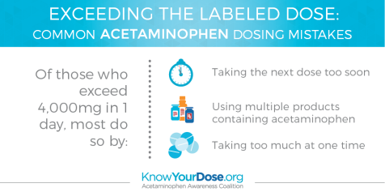 | You’ve heard them before. Here's how to help patients avoid these common acetaminophen dosing pitfalls: http://bit.ly/KYD-providers #KYDcoldflu
Facebook |  | You’ve likely heard these common acetaminophen dosing pitfalls before. Here’s how to help your patients avoid accidentally exceeding the labeled dose: http://bit.ly/KYD-providers #KYDcoldflu
Twitter | 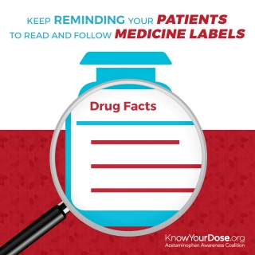 | Urging patients to read medicine labels is so important during cold & flu season. These tools can help: http://bit.ly/KYD-order #KYDcoldflu
Facebook |  | Encouraging patients to read and follow their medicines labels is so important during cold and flu season. Here are some tools to help spark that conversation: http://bit.ly/KYD-order #KYDcoldflu

Content for Newsletters, Blogs, and Websites

Your Patients’ Cold and Flu Season Survival Guide

Cold and flu season is here again, which means we as healthcare professionals are on especially high alert for potential dosing mistakes among our patients. Seven in 10 will use over-the-counter (OTC) medicines to treat their cold and flu symptoms, and research shows that consumers don’t always know that taking two medicines with the same ingredient could be harmful, and two in three consumers don’t consider other OTC medicines they’re taking when choosing an OTC pain reliever.

The CDC expects the cold and flu season will peak this year between December and March, so now is the time to remind your patients that many multi-symptom cold and flu medicines contain the common drug ingredient acetaminophen. In fact, acetaminophen is found in more than 600 different OTC and prescription medicines. It’s safe and effective when used as directed, but patients who take medicines with acetaminophen for everyday pain relief may not realize they risk accidentally doubling their dose by taking certain cold and flu medicines. Make sure your patients know that the U.S. Food and Drug Administration has set a maximum daily dose of 4,000 milligrams (mg) of acetaminophen in a 24-hour period, and taking more than directed can lead to liver damage.

These core safe use steps from the Know Your Dose campaign, of which [ORG NAME] is a proud partner, will help your patients use medicines with acetaminophen safely:
- Always read and follow the label.
- Know if your medicines contain acetaminophen.
- Take only one medicine at a time that contains acetaminophen.
- Ask your healthcare provider or a pharmacist if you have questions about dosing instructions or medicines that contain acetaminophen.

Order free educational materials on acetaminophen safe use for your office or pharmacy at KnowYourDose.org and follow @KnowYourDose on Twitter.

